Packet Tracer – Configuring Multiarea OSPFv2 Topology

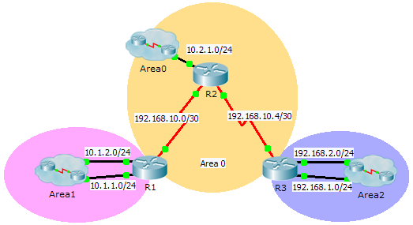

1. Addressing Table

|  |  |  |  |  |
| --- | --- | --- | --- | --- |
| Device | Interface | IP Address | Subnet Mask | OSPFv2 Area |
| R1 | G0/0 | 10.1.1.1 | 255.255.255.0 | 1 |
| G0/1 | 10.1.2.1 | 255.255.255.0 | 1 |
| S0/0/0 | 192.168.10.2 | 255.255.255.252 | 0 |
| R2 | G0/0 | 10.2.1.1 | 255.255.255.0 | 0 |
| S0/0/0 | 192.168.10.1 | 255.255.255.252 | 0 |
| S0/0/1 | 192.168.10.5 | 255.255.255.252 | 0 |
| R3 | G0/0 | 192.168.2.1 | 255.255.255.0 | 2 |
| G0/1 | 192.168.1.1 | 255.255.255.0 | 2 |
| S0/0/1 | 192.168.10.6 | 255.255.255.252 | 0 |

1. Objectives

Part 1: Configure Multiarea OSPFv2

Part 2: Verify and Examine Multiarea OSPFv2

1. Background

In this activity, you will configure multiarea OSPFv2. The network is already connected and interfaces are configured with IPv4 addressing. Your job is to enable multiarea OSPFv2, verify connectivity, and examine the operation of multiarea OSPFv2.

1. Configure OSPFv2
   1. Configure OSPFv2 on R1.

Configure OSPFv2 on R1 with a process ID of 1 and a router ID of 1.1.1.1.

R1(config)# **router ospf 1**

R1(config-router)# **router-id 1.1.1.1**

* 1. Advertise each directly connected network in OSPFv2 on R1.

Configure each network in OSPFv2 assigning areas according to the **Addressing Table**.

R1(config-router)# **network 10.1.1.0 0.0.0.255 area 1**

R1(config-router)# **network 10.1.2.0 0.0.0.255 area 1**

R1(config-router)# **network 192.168.10.0 0.0.0.3 area 0**

* 1. Configure OSPFv2 on R2 and R3.

Repeat the steps above for **R2** and **R3** using a router ID of 2.2.2.2 and 3.3.3.3, respectively.

R2(config)# **router ospf 1**

R2(config-router)# **router-id 2.2.2.2**

R2(config-router)# **network 10.2.1.0 0.0.0.255 area 0**

R2(config-router)# **network 192.168.10.0 0.0.0.3 area 0**

R2(config-router)# **network 192.168.10.4 0.0.0.3 area 0**

!

R3(config)# **router ospf 1**

R3(config-router)# **router-id 3.3.3.3**

R3(config-router)# **network 192.168.2.0 0.0.0.255 area 2**

R3(config-router)# **network 192.168.1.0 0.0.0.255 area 2**

R3(config-router)# **network 192.168.10.4 0.0.0.3 area 0**

1. Verify and Examine Multiarea OSPFv2
   1. Verify connectivity to each of the OSPFv2 areas.

From R1, ping each of the following remote devices in area 0 and area 2: 192.168.1.2, 192.168.2.2, and 10.2.1.2.

* 1. Use show commands to examine the current OSPFv2 operations.

Use the following commands to gather information about your OSPFv2 multiarea implementation.

**show ip protocols**

**show ip route**

**show ip ospf database**

**show ip ospf interface**

show ip ospf neighbor